**ZOMATO RESTAURANT ANALYSIS**

**Objective Questions**:

1. The data consists of some inconsistent and missing values so ensure that the data used for further analysis is cleaned.

* Removed records where values for cuisine column were blank.
* Removed records where average cost for two column has value as 0

1. Using the LookUp functions, fill up the countries in the original data using the country code.

Formula Used:

=VLOOKUP(C3,'country description'!$A$2:$B$16,2,0)

1. Create a table to represent the number of restaurants opened in each country.

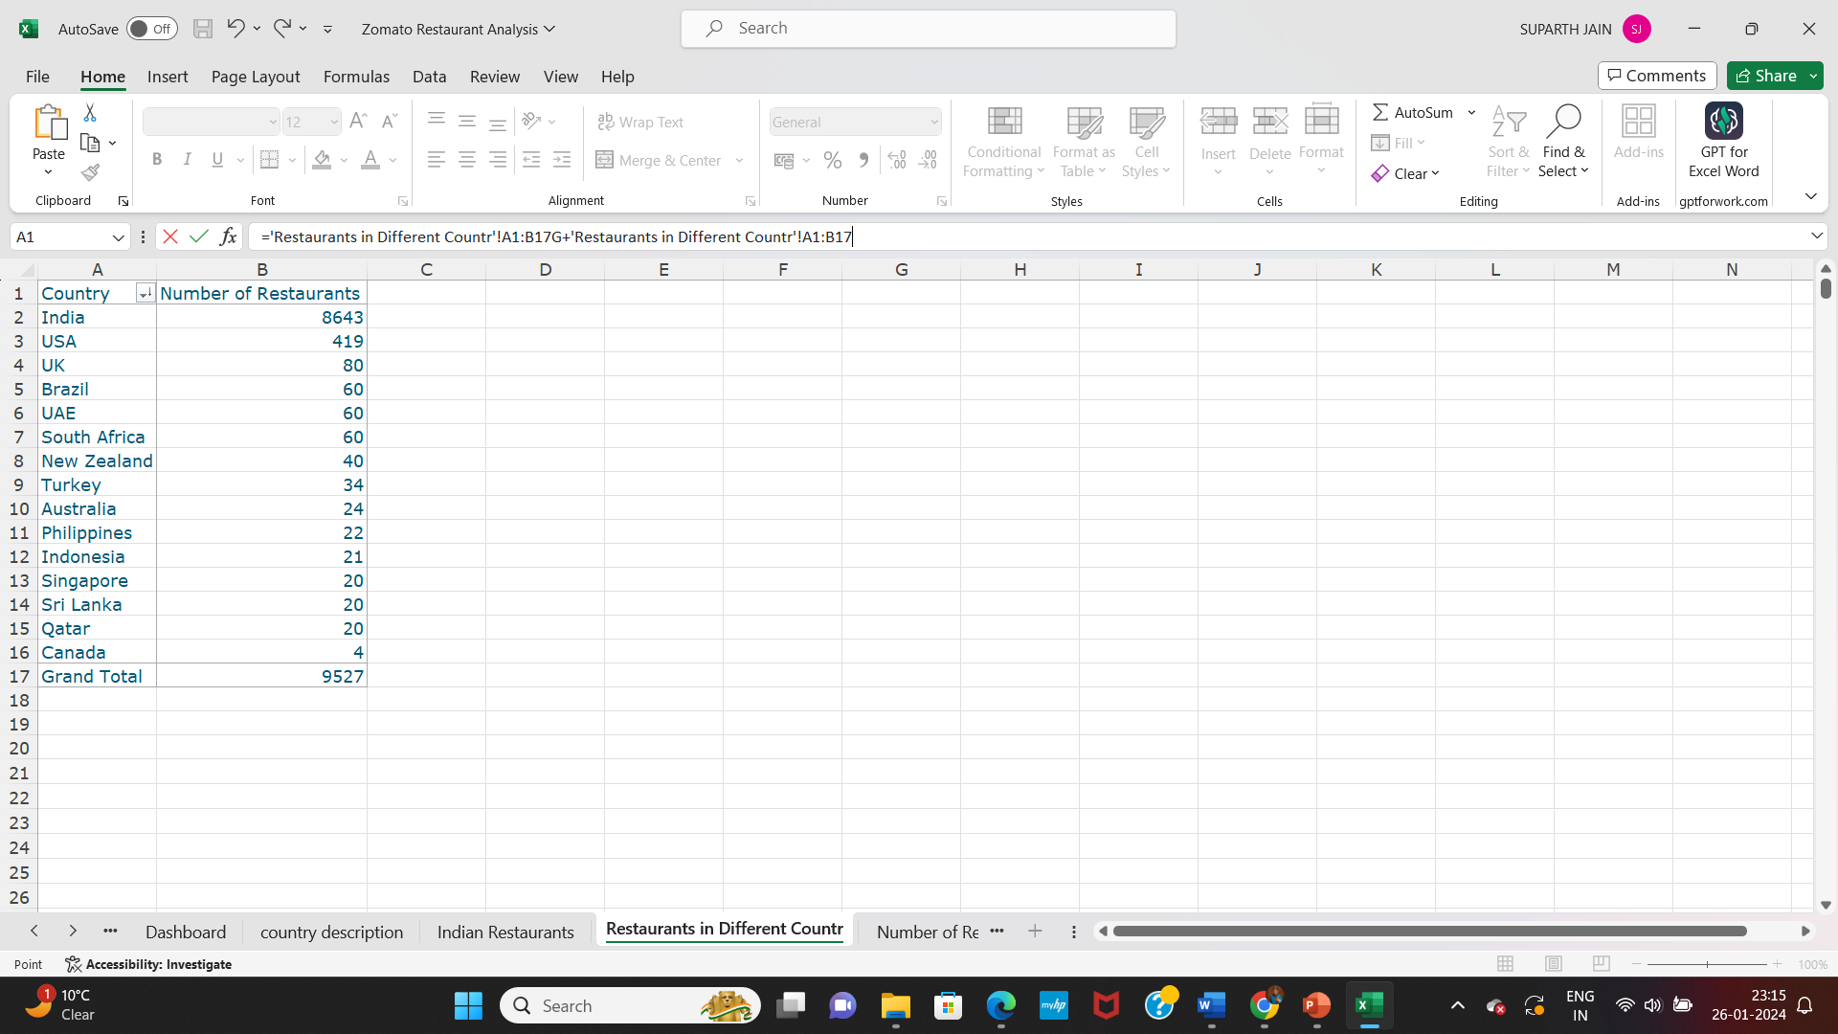

1. Also, the management wants to look at the number of restaurants opened in each year, so provide them with something here.

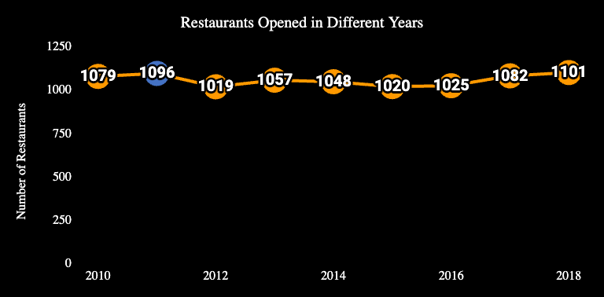

1. What is the total number of restaurants in India in the price range of 4?

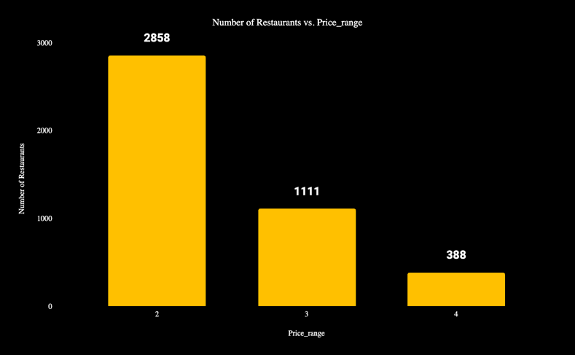

There are 388 restaurants in India which are in the price range of 4

1. According to the data, what is the average number of voters for the restaurants in each country?

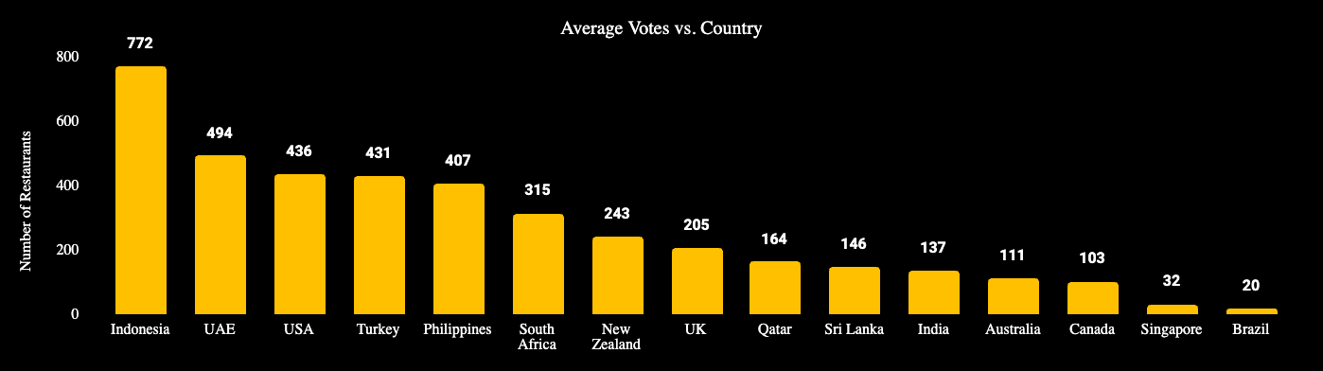

**Subjective Question:**

1. Suggest a few countries where the team can open newer restaurants with lesser competition. Which visualization/technique will you use here to justify the suggestions?

**There are few parameters which can be considered to decide the countries to open restaurants with lesser competition:**

* Country where less number of restaurants are there
* Countries where density of restaurants is less (Density here means the ratio of number of restaurants with number of cities in a country)
* Average Cost of Food : Restaurants with less average cost of food providing good quality should be considered for attracting more customers and reduce competitions.

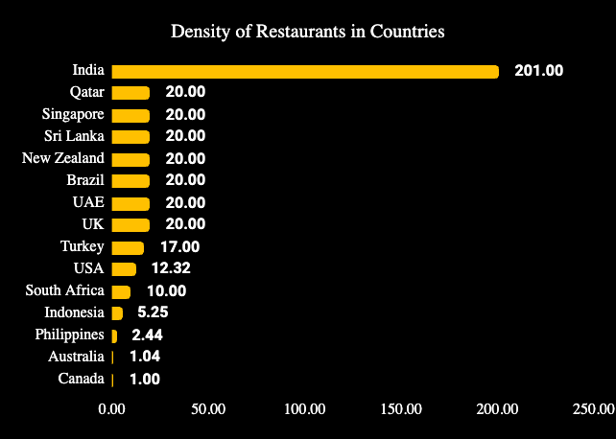

From studying the above two graphs, the countries suitable to open new restaurants with lesser competition are:

* Canada
* Australia
* Philippines
* Indonesia

Now further studying these 4 countries on the basis of average cost of food and ratings can be helpful to further increase the possibility of setting up the restaurant at most correct place.

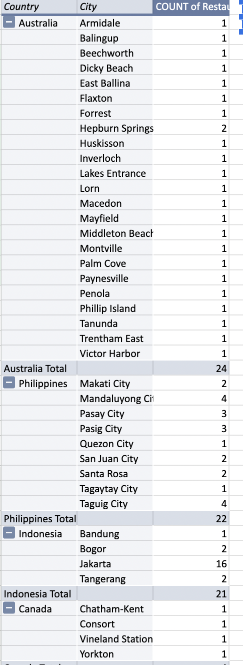

1. Come up with the names of States and cities in the suggested countries suitable for opening restaurants.

Canada Data:

|  |  |
| --- | --- |
| City | Total |
| Yorkton | 1 |
| Vineland Station | 1 |
| Chatham-Kent | 1 |
| Consort | 1 |

Australia Data:

|  |  |
| --- | --- |
| City | Total |
| Hepburn Springs | 2 |
| Balingup | 1 |
| Macedon | 1 |
| Trentham East | 1 |
| Beechworth | 1 |
| Middleton Beach | 1 |
| Dicky Beach | 1 |
| Phillip Island | 1 |
| East Ballina | 1 |
| Armidale | 1 |
| Flaxton | 1 |
| Mayfield | 1 |
| Forrest | 1 |
| Montville | 1 |
| Palm Cove | 1 |
| Paynesville | 1 |
| Penola | 1 |
| Huskisson | 1 |
| Tanunda | 1 |
| Inverloch | 1 |
| Victor Harbor | 1 |
| Lakes Entrance | 1 |
| Lorn | 1 |

Philippines Data:

|  |  |
| --- | --- |
| City | Total |
| Taguig City | 4 |
| Mandaluyong City | 4 |
| Pasay City | 3 |
| Pasig City | 3 |
| Makati City | 2 |
| Santa Rosa | 2 |
| San Juan City | 2 |
| Tagaytay City | 1 |
| Quezon City | 1 |

Indonesia Data:

|  |  |
| --- | --- |
| City | Total |
| Jakarta | 16 |
| Tangerang | 2 |
| Bogor | 2 |
| Bandung | 1 |

From the above tables, some of the cities where the restaurants can be opened:

* Canada: Yorkton, Vineland Station, Chatham-Kent, Consort
* Australia: Lorn, Lakes Entrance, Victor Harber, Inverloch
* Philippines: Quezon City, Tagaytay City, SanJuan City, Santa Rosa, Makati City
* Indonesia: Bandung, Bogor, Tangerang

Now further reducing the number of options and increasing the chances of setting up the restaurants at the most correct place by analyzing average cost of food and ratings

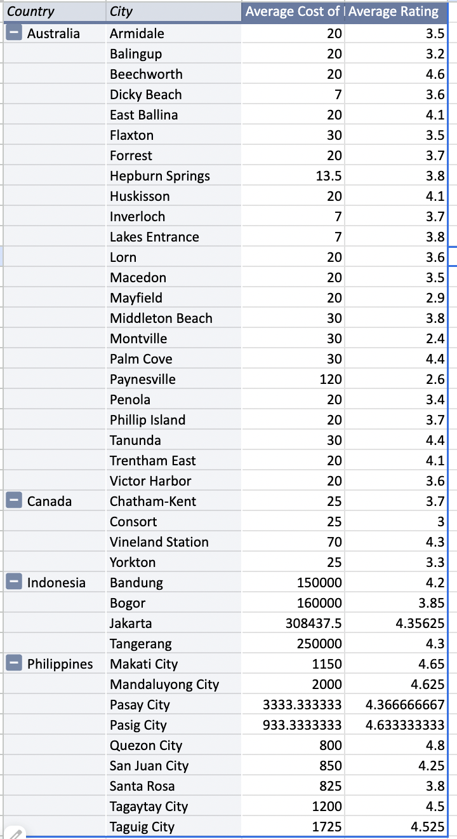

In Canada :

Consort, Yorkton & Chatham-Kent have low average cost with avg. rating of 3.33. So if restaurant at these three cities with same average cost and rating around 4 can be a good option.

In Philippines:

Quezan City will provide very high competition as average cost is the least and the rating is maximum. So eliminating this option.  
Santa Rosa can be preferred in Philippines, if quality of food is taken care of and keeping the average cost between 800-850 can give good response

In Indonesia:

Same as Philippines, in city Bogor, if quality of food is taken care of with average cost of somewhere around 150000 (local currency) can give a good result

In Australia:

Most of the city have an average cost of food as $20 and rating is also somewhere between 3-4  
But considering Armidale city, which has $20 average cost of food but rating is not good. So opening a restaurant here with better quality of food in the similar price range can be really a great option to set up restaurant.

So final list of cities :  
  
Australia : Armidale

Canada : Consort, Yorkton & Chatham-Kent

Philippines: Santa Rosa

Indonesia : Bogor

The above cities are preferred because these cities contain least number of restaurants in their respective countries, so there will be less competition as compared to other cities.

1. According to the countries you suggested, what is the current quality regarding ratings for restaurants that are open there?

|  |  |
| --- | --- |
| Country | Total |
| Australia | 3.66 |
| Canada | 3.58 |
| Indonesia | 4.30 |
| Philippines | 4.47 |

For the countries suggested to open new restaurants, the above table displays the average rating given by the customers to the restaurants which defines the quality of the food. Out of the 4 suggested countries, Philippines have the best quality of food with an Average Rating of 4.47 and Australia have the least quality of food with an Average Rating of 3.66

1. Also, what is the current expenditure on food in the suggested countries, so we can keep our financial expenditure in control?

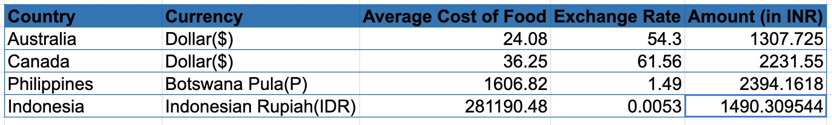

The expenditure on food is very high in Philippines where as its least in Australia.

Note: The amounts displayed are in the INR as per the exchange rates dated 29-March-2024. To get the live exchange rates, we can import data from API which provides in our database.

1. Come up with the names of restaurants from the recommended states that are our biggest competitors and also those that are rated in the lower brackets, i.e. 1-2 or 2-3.

For Country Canada:

|  |  |  |  |  |  |
| --- | --- | --- | --- | --- | --- |
| **RestaurantName** | **Country** | **Price_range** | **Average_Cost_for_two** | **Rating** | **Rating Category** |
| Lake House Restaurant | Canada | 4 | 70 | 4.3 | Very Good |
| Tokyo Sushi | Canada | 2 | 25 | 3.7 | Good |
| Arigato Sushi | Canada | 2 | 25 | 3.3 | Good |
| Consort Restaurant | Canada | 2 | 25 | 3.0 | Good |

In Canada, Tokyo Sushi, Arigato Sushi and Consort Restaurant are our biggest competitors as they have less average cost of food and also they have Good Ratings.

In Canada, there are no restaurants which are rated in the lower bracket of 1-2.

For Country Indonesia:

|  |  |  |  |  |  |
| --- | --- | --- | --- | --- | --- |
| **RestaurantName** | **Country** | **Price_range** | **Average_Cost_for_two** | **Rating** | **Rating Category** |
| Momo Milk | Indonesia | 2 | 70000 | 3.7 | Good |
| Fish Streat | Indonesia | 3 | 100000 | 4.0 | Very Good |
| Fish Streat | Indonesia | 3 | 100000 | 3.4 | Good |
| Flip Burger | Indonesia | 3 | 120000 | 4.4 | Very Good |

In Indonesia, the above restaurants are biggest restaurants, as they have least cost for food among all the restaurants of Indonesia. Also they have good and very good rating.

In Indonesia, there is no restaurant in lower brackets of rating

For Country Philippines:

|  |  |  |  |  |  |
| --- | --- | --- | --- | --- | --- |
| **RestaurantName** | **Country** | **Price_range** | **Average_Cost_for_two** | **Rating** | **Rating Category** |
| Hobing Korean Dessert Cafe | Philippines | 2 | 600 | 4.5 | Excellent |
| Sodam Korean Restaurant | Philippines | 3 | 700 | 4.3 | Very Good |
| Silantro Fil-Mex | Philippines | 3 | 800 | 4.9 | Excellent |
| Cafe Arabelle | Philippines | 3 | 800 | 3.6 | Good |
| Silantro Fil-Mex | Philippines | 3 | 800 | 4.8 | Excellent |

In Philippines, the above restaurants are biggest restaurants, as they have least cost for food among all the restaurants of Philippines. Also they have very good and very excellent rating.

In Philippines, there is no restaurant in lower brackets of rating.

For Country Australia:

|  |  |  |  |  |  |
| --- | --- | --- | --- | --- | --- |
| **RestaurantName** | **Country** | **Price_range** | **Average_Cost_for_two** | **Rating** | **Rating Category** |
| Bridge Road Brewers | Australia | 2 | 20 | 4.6 | Excellent |
| 1918 Bistro & Grill | Australia | 3 | 30 | 4.4 | Very Good |
| Vivo Bar and Grill | Australia | 3 | 30 | 4.4 | Very Good |
| The Belle General | Australia | 2 | 20 | 4.1 | Very Good |
| 5 Little Pigs | Australia | 2 | 20 | 4.1 | Very Good |
| Pig and Whistle | Australia | 2 | 20 | 4.1 | Very Good |
| La Trattoria of Lavandula | Australia | 1 | 7 | 3.8 | Good |
| Funkey Monkey | Australia | 1 | 7 | 3.8 | Good |

In Australia, the above restaurants are biggest restaurants, as they have least cost for food among all the restaurants of Australia. Also they have very good rating on average.

|  |  |  |  |  |  |
| --- | --- | --- | --- | --- | --- |
| **RestaurantName** | **Country** | **Price_range** | **Average_Cost_for_two** | **Rating** | **Rating Category** |
| Poets Cafe | Australia | 3 | 30 | 2.4 | Average |
| Pier 70 | Australia | 4 | 120 | 2.6 | Average |
| Star Buffet | Australia | 2 | 20 | 2.9 | Average |

The above restaurants falls in the lower bracket of rating 2-3. But there are no restaurants in the category of 1-2.

1. Which cuisines should we focus on in the newer restaurants to get better feedback? Does the choice of cuisines affect the restaurant ratings?

Preferred Cuisines for Australia:

|  |
| --- |
| **Cuisines** |
| Pizza, Bar Food |
| Modern Australian, Australian |
| Mediterranean, Seafood |
| Cafe |
| Breakfast, Modern Australian |
| Australian |
| Italian, Fusion, Cafe |

Preferred Cuisines for Canada:

|  |
| --- |
| **Cuisines** |
| Italian, Mediterranean, Pizza |
| Japanese, Sushi |
| Asian |
| Chinese, Canadian |

Preferred Cuisines For Indonesia:

|  |
| --- |
| **Cuisines** |
| Cafe, Desserts, Beverages |
| Seafood, Western |
| Seafood, Western |
| Burger |
| Cafe, Coffee and Tea, Western |
| Cafe, Italian, Coffee and Tea, Western, Indonesian |

Preferred Cuisines for Philippines:

|  |
| --- |
| **Cuisines** |
| Cafe, Korean, Desserts |
| Korean |
| Filipino, Mexican |
| Cafe, American, Italian, Filipino |
| Filipino, Mexican |
| Italian, Pizza |

Cuisines does not have much effect on ratings. Because the pattern of cuisines inferences that same cuisines in two different restaurants have negative correlation between each other.

1. According to our current data, should we go for online delivery and table booking? Does that affect the customer’s ratings?

Yes, we should go for online delivery and table booking. These two features are not available in most of the restaurants. And adding these two features in our restaurant will definitely make the restaurant more preferred as compared to other restaurants.

Yes, having online delivery and table booking increase the rating of the restaurant.

1. Should the team keep the rate of cuisines higher? Will that affect the feedback? According to our data are the rates of cuisines and ratings, correlated?

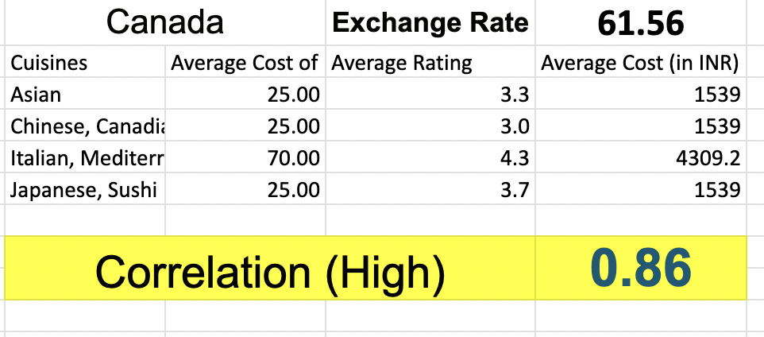

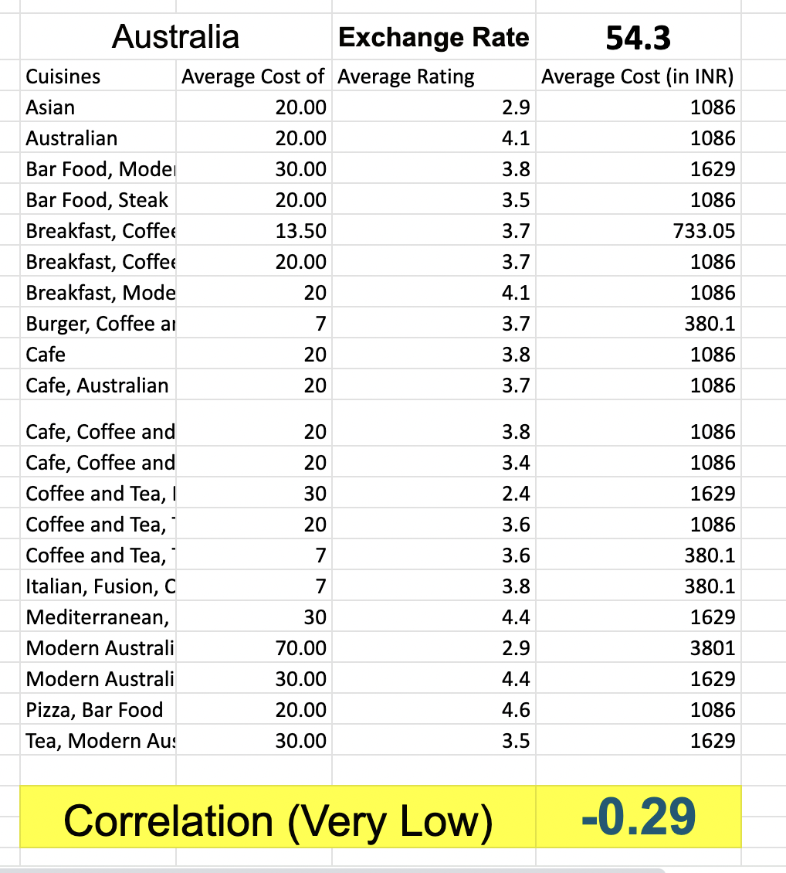

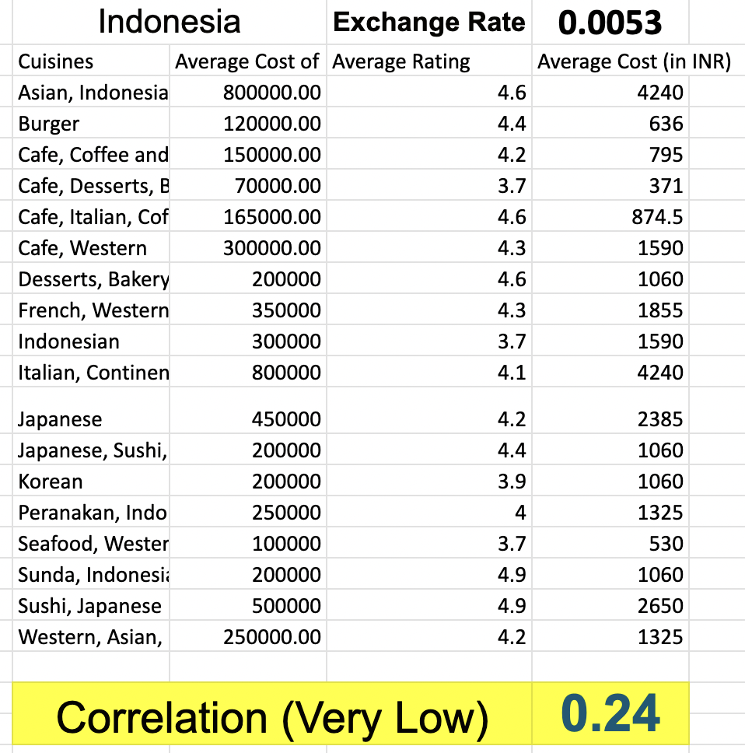

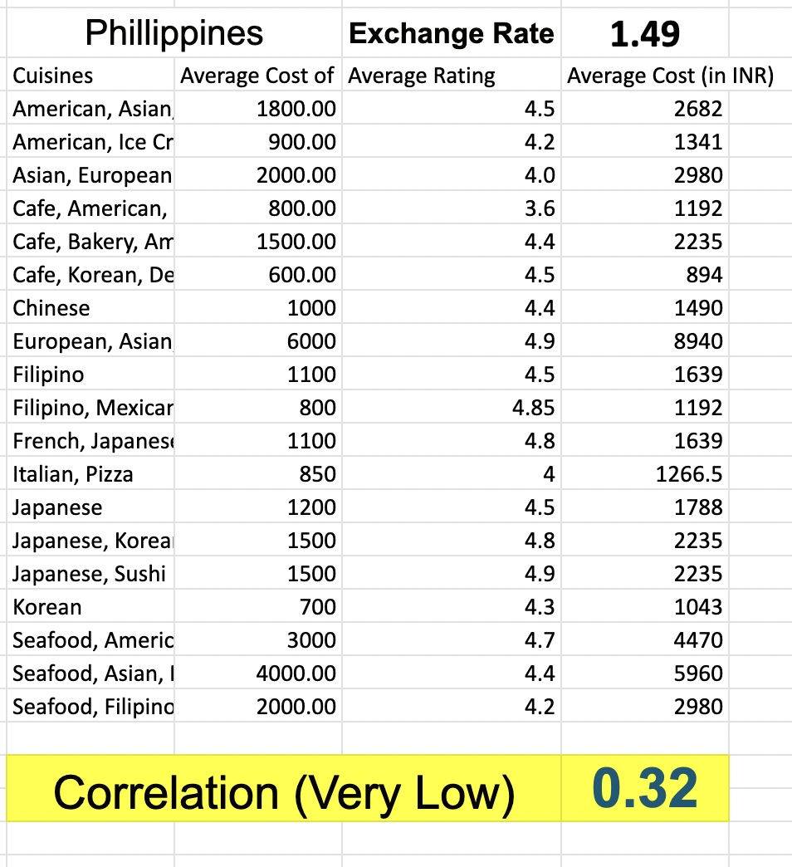

**Cuisines Price can be higher for the restaurant in Canada as the cost is highly correlated with rating. But for other countries, there is no correlation/very less correlation. So keeping prices higher is not a good idea.**

1. What is the distribution of a number of restaurants of different price ranges in all the countries?

